Analysis Report
1. Identifying patterns of donor behaviour
Query 1.1 - Channel engagement segments
CREATE OR REPLACE VIEW `assignment-3-474608.assign3.vw_engagement_segments` AS
WITH
trad AS (
SELECT
Customer_ID,
COUNTIF(DonationAmount > 0) AS trad_txn_count,
SUM(DonationAmount) AS trad_total_amount,
MAX(DATE(DonationDate)) AS trad_last_date
FROM `assignment-3-474608.assign3.Tradition_Donation_Patterns`
GROUP BY Customer_ID
),
iap AS (
SELECT
Customer_ID,
COUNTIF(InAppPurchaseAmount > 0) AS iap_txn_count,
SUM(InAppPurchaseAmount) AS iap_total_amount,
MAX(DATE(LastPurchaseDate)) AS iap_last_date
FROM `assignment-3-474608.assign3.Mobile_Game_Inapp_Purchases`
GROUP BY Customer_ID
)
SELECT
c.Customer_ID,
COALESCE(t.trad_txn_count, 0) AS trad_txn_count,
COALESCE(t.trad_total_amount,0) AS trad_total_amount,
t.trad_last_date,
COALESCE(i.iap_txn_count, 0) AS iap_txn_count,
COALESCE(i.iap_total_amount,0) AS iap_total_amount,
i.iap_last_date,
CASE
WHEN COALESCE(t.trad_txn_count,0) > 0 AND COALESCE(i.iap_txn_count,0) > 0 THEN 'Omnichannel'
WHEN COALESCE(t.trad_txn_count,0) > 0 AND COALESCE(i.iap_txn_count,0) = 0 THEN 'Traditional-only'
WHEN COALESCE(t.trad_txn_count,0) = 0 AND COALESCE(i.iap_txn_count,0) > 0 THEN 'In-app-only'
ELSE 'No-activity'
END AS EngagementSegment
FROM `assignment-3-474608.assign3.Customers` c
LEFT JOIN trad t USING (Customer_ID)
LEFT JOIN iap i USING (Customer_ID);

SELECT * FROM `assignment-3-474608.assign3.vw_engagement_segments` LIMIT 20;

Output
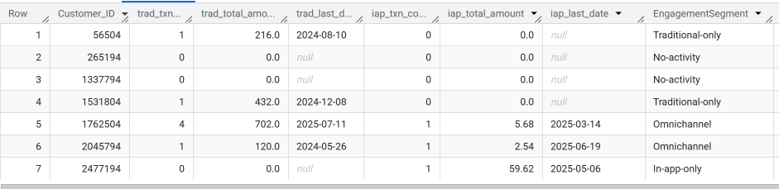

Visualisation

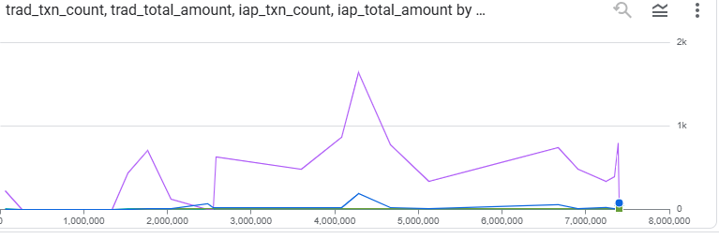

Query 1.2 - Customer-level RFM (Recency, Frequency, Monetary) with quintiles
CREATE OR REPLACE VIEW `assignment-3-474608.assign3.vw_customer_rfm` AS
WITH
last_trad AS (
SELECT
Customer_ID,
MAX(DATE(DonationDate)) AS last_trad_date,
COUNT(*) AS trad_freq,
SUM(DonationAmount) AS trad_monetary
FROM
`assignment-3-474608`.assign3.Tradition_Donation_Patterns
GROUP BY Customer_ID
),
last_iap AS (
SELECT
Customer_ID,
MAX(DATE(LastPurchaseDate)) AS last_iap_date,
COUNTIF(InAppPurchaseAmount > 0) AS iap_freq,
SUM(InAppPurchaseAmount) AS iap_monetary
FROM
`assignment-3-474608`.assign3.Mobile_Game_Inapp_Purchases
GROUP BY Customer_ID
),
base AS (
SELECT
c.Customer_ID,
GREATEST(IFNULL(last_trad_date, DATE '1900-01-01'), IFNULL(last_iap_date, DATE '1900-01-01')) AS last_activity_date,
IFNULL(trad_freq, 0) + IFNULL(iap_freq, 0) AS frequency,
IFNULL(trad_monetary, 0) + IFNULL(iap_monetary, 0) AS monetary
FROM
`assignment-3-474608`.assign3.Customers AS c
LEFT JOIN
last_trad
USING(Customer_ID)
LEFT JOIN
last_iap
USING(Customer_ID)
),
scored AS (
SELECT
*,
DATE_DIFF(DATE '2025-08-31', last_activity_date, DAY) AS recency_days
FROM
base
),
q AS (
SELECT
s.*,
NTILE(5) OVER (
ORDER BY recency_days) AS R_score,
NTILE(5) OVER (
ORDER BY frequency) AS F_score,
NTILE(5) OVER (
ORDER BY monetary) AS M_score
FROM
scored AS s
)
SELECT
Customer_ID,
recency_days,
frequency,
monetary,
R_score,
F_score,
M_score,
(R_score + F_score + M_score) AS RFM_total
FROM
q;

SELECT * FROM `assignment-3-474608.assign3.vw_customer_rfm` ORDER BY RFM_total DESC LIMIT 20;

Output

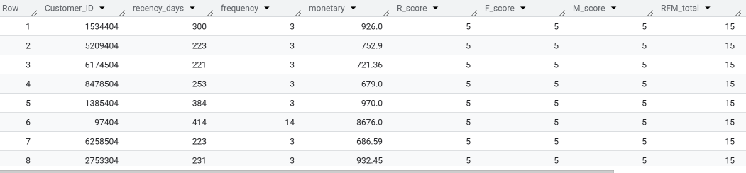

Visualisation

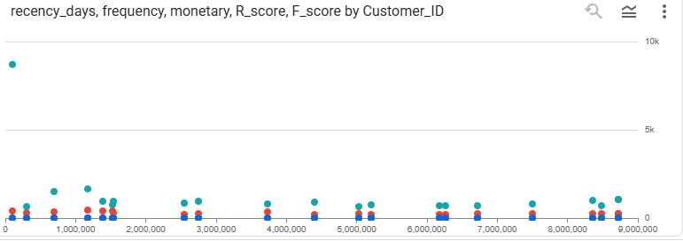

Query 1.3 - Monthly revenue by channel + contribution share
CREATE OR REPLACE VIEW `assignment-3-474608.assign3.vw_monthly_revenue` AS
WITH
trad AS (
SELECT
DATE_TRUNC(DATE(DonationDate), MONTH) AS month,
SUM(DonationAmount) AS traditional_revenue
FROM `assignment-3-474608.assign3.Tradition_Donation_Patterns`
GROUP BY month
),
iap AS (
SELECT
DATE_TRUNC(DATE(LastPurchaseDate), MONTH) AS month,
SUM(InAppPurchaseAmount) AS inapp_revenue
FROM `assignment-3-474608.assign3.Mobile_Game_Inapp_Purchases`
WHERE LastPurchaseDate IS NOT NULL
GROUP BY month
)
SELECT
COALESCE(trad.month, iap.month) AS month,
IFNULL(traditional_revenue,0) AS traditional_revenue,
IFNULL(inapp_revenue,0) AS inapp_revenue,
IFNULL(traditional_revenue,0) + IFNULL(inapp_revenue,0) AS total_revenue,
SAFE_DIVIDE(IFNULL(traditional_revenue,0),
NULLIF(IFNULL(traditional_revenue,0)+IFNULL(inapp_revenue,0),0)) AS traditional_share,
SAFE_DIVIDE(IFNULL(inapp_revenue,0),
NULLIF(IFNULL(traditional_revenue,0)+IFNULL(inapp_revenue,0),0)) AS inapp_share
FROM trad
FULL JOIN iap
ON trad.month = iap.month;

SELECT * FROM `assignment-3-474608.assign3.vw_monthly_revenue` ORDER BY month LIMIT 20;

Output

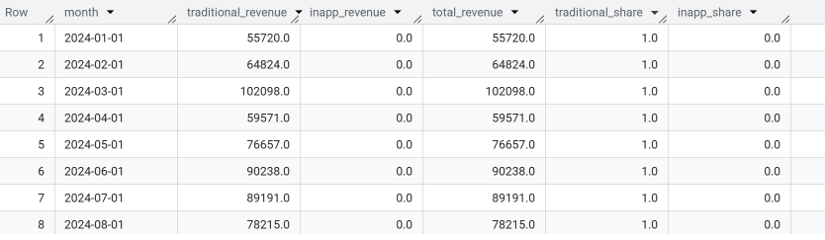

Visualisation

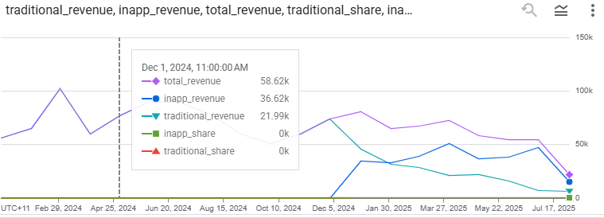

Query 1.4 - Behavioural cohorts (first-gift month) & retention by month-since-cohort
CREATE OR REPLACE VIEW `assignment-3-474608.assign3.vw_cohort_retention` AS
WITH
first_txn AS (
SELECT
Customer_ID,
DATE_TRUNC(MIN(DATE(DonationDate)), MONTH) AS first_month
FROM `assignment-3-474608.assign3.Tradition_Donation_Patterns`
GROUP BY Customer_ID
),
activity AS (
SELECT
t.Customer_ID,
DATE_TRUNC(DATE(t.DonationDate), MONTH) AS act_month
FROM `assignment-3-474608.assign3.Tradition_Donation_Patterns` t
),
joined AS (
SELECT
f.first_month,
a.act_month,
DATE_DIFF(a.act_month, f.first_month, MONTH) AS months_since_cohort,
a.Customer_ID
FROM activity a
JOIN first_txn f USING (Customer_ID)
)
SELECT
first_month,
months_since_cohort,
COUNT(DISTINCT Customer_ID) AS active_customers
FROM joined
GROUP BY first_month, months_since_cohort
ORDER BY first_month, months_since_cohort;

SELECT * FROM `assignment-3-474608.assign3.vw_cohort_retention` LIMIT 20;

Output

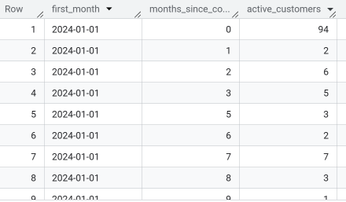

Visualisation

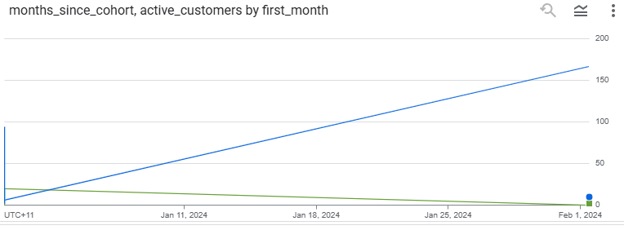

Query 1.5 - Campaign performance
CREATE OR REPLACE VIEW `assignment-3-474608.assign3.vw_campaign_performance` AS
WITH
resp AS (
SELECT
Customer_ID,
Campaign_ID,
`IF`(Response, 1, 0) AS responded,
ClickThroughRate,
EngagementFrequency
FROM
`assignment-3-474608`.assign3.Campaign_Response
)
SELECT
r.Campaign_ID,
m.CampaignType,
m.CampaignDate,
m.CampaignBudget,
COUNT(DISTINCT r.Customer_ID) AS audience,
SUM(r.responded) AS responses,
AVG(r.ClickThroughRate) AS avg_ctr,
AVG(r.EngagementFrequency) AS avg_engagement,
SAFE_DIVIDE(SUM(r.responded), COUNT(DISTINCT r.Customer_ID)) AS response_rate,
SAFE_DIVIDE(SUM(r.responded), NULLIF(m.CampaignBudget / 1000, 0)) AS responses_per_1k
FROM
resp AS r
LEFT JOIN
`assignment-3-474608`.assign3.Marketing_Campaigns AS m
ON r.Campaign_ID = m.Campaign_ID
GROUP BY r.Campaign_ID, m.CampaignType, m.CampaignDate, m.CampaignBudget
ORDER BY responses_per_1k DESC;

SELECT * FROM `assignment-3-474608.assign3.vw_campaign_performance` LIMIT 20;

Output

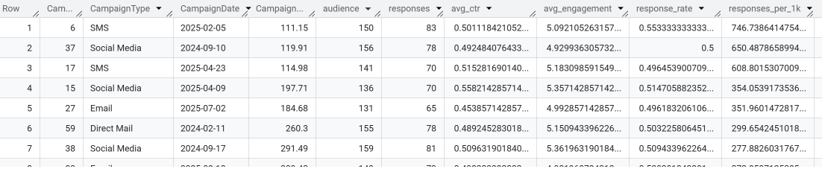

Visualisation

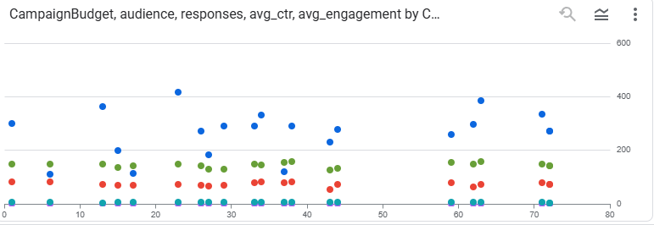

Query 1.6 - Campaign response by RFM tier
CREATE OR REPLACE VIEW `assignment-3-474608.assign3.vw_campaign_by_rfm` AS
WITH
rfm AS (SELECT * FROM `assignment-3-474608.assign3.vw_customer_rfm`),
resp AS (
SELECT
Customer_ID,
Campaign_ID,
IF(LOWER(TRIM(CAST(Response AS STRING))) IN ('yes','y','1','true'), 1, 0) AS responded
FROM `assignment-3-474608.assign3.Campaign_Response`
)
SELECT
m.Campaign_ID,
m.CampaignType,
APPROX_QUANTILES(rfm.RFM_total, 5)[OFFSET(3)] AS rfm_median,
AVG(resp.responded) AS response_rate,
COUNT(DISTINCT resp.Customer_ID) AS audience
FROM `assignment-3-474608.assign3.Marketing_Campaigns` m
JOIN resp USING (Campaign_ID)
LEFT JOIN rfm ON rfm.Customer_ID = resp.Customer_ID
GROUP BY Campaign_ID, CampaignType
ORDER BY response_rate DESC;

SELECT * FROM `assignment-3-474608.assign3.vw_campaign_by_rfm` LIMIT 20;

Output

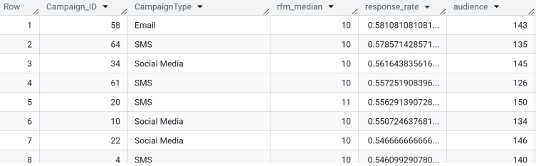

Visualisation

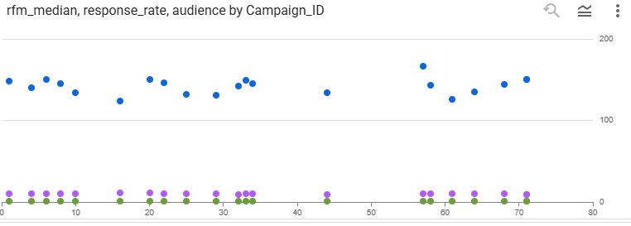
2 - Analysing and reducing donor churn
Query 2.1- Churned members
CREATE OR REPLACE VIEW `assignment-3-474608.assign3.vw_churned_members` AS
SELECT
Customer_ID,
MAX(DATE(DonationEndDate)) AS last_end_date
FROM
`assignment-3-474608`.assign3.Tradition_Donation_Patterns
WHERE
LOWER(Product) = 'membership' AND DonationEndDate IS NOT NULL AND DATE(DonationEndDate) <= DATE '2025-08-31'
GROUP BY Customer_ID;

SELECT * FROM `assignment-3-474608.assign3.vw_churned_members` LIMIT 20;

Output

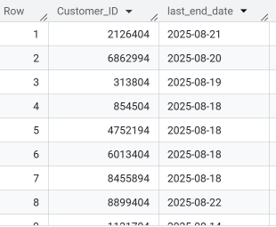
Visualisation 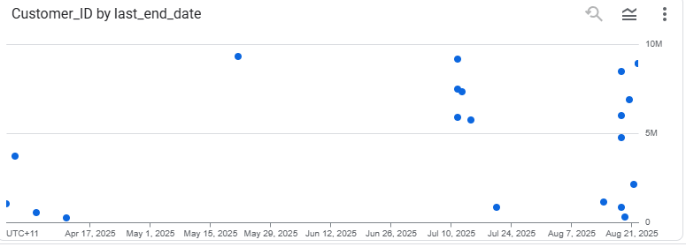
Query 2.2 - Active members (no end date recorded)

CREATE OR REPLACE VIEW `assignment-3-474608.assign3.vw_active_members` AS
SELECT
Customer_ID,
MAX(DATE(DonationDate)) AS last_payment_date
FROM `assignment-3-474608.assign3.Tradition_Donation_Patterns`
WHERE LOWER(Product) = 'membership'
AND DonationEndDate IS NULL
GROUP BY Customer_ID;

SELECT * FROM `assignment-3-474608.assign3.vw_active_members` LIMIT 20;

Output
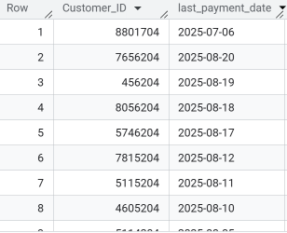

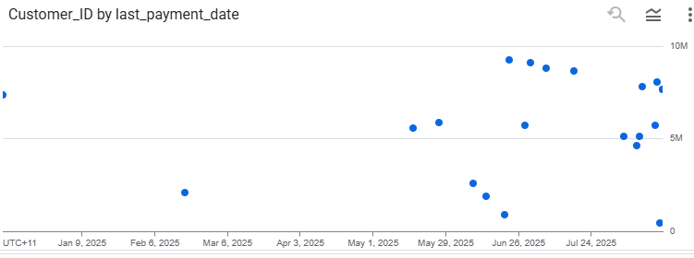
Visualisation
Query 2.3 - Inactivity churners

CREATE OR REPLACE VIEW `assignment-3-474608.assign3.vw_inactivity_churn` AS
WITH
last_trad AS (
SELECT
Customer_ID,
MAX(DATE(DonationDate)) AS last_trad
FROM
`assignment-3-474608`.assign3.Tradition_Donation_Patterns
GROUP BY Customer_ID
),
last_iap AS (
SELECT
Customer_ID,
MAX(DATE(LastPurchaseDate)) AS last_iap
FROM
`assignment-3-474608`.assign3.Mobile_Game_Inapp_Purchases
GROUP BY Customer_ID
),
last_act AS (
SELECT
c.Customer_ID,
GREATEST(IFNULL(last_trad.last_trad, DATE '1900-01-01'), IFNULL(last_iap.last_iap, DATE '1900-01-01')) AS last_activity
FROM
`assignment-3-474608`.assign3.Customers AS c
LEFT JOIN
last_trad
USING(Customer_ID)
LEFT JOIN
last_iap
USING(Customer_ID)
)
SELECT
Customer_ID,
last_activity,
DATE_DIFF(DATE '2025-08-31', last_activity, DAY) AS days_inactive
FROM
last_act
WHERE
DATE_DIFF(DATE '2025-08-31', last_activity, DAY) >= 180;

SELECT * FROM `assignment-3-474608.assign3.vw_inactivity_churn` ORDER BY days_inactive DESC LIMIT 20;

Output

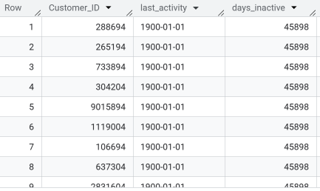

Visualisation

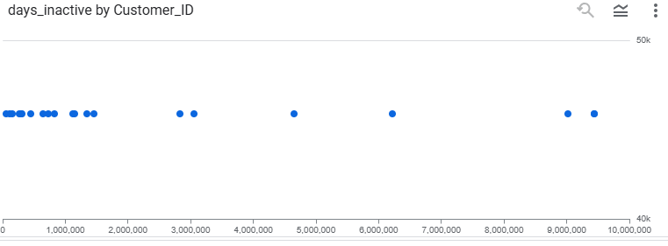

2.4- Churn-risk save list
CREATE OR REPLACE VIEW `assignment-3-474608.assign3.vw_churn_risk_save_list` AS
WITH
rfm AS (
SELECT
*
FROM
`assignment-3-474608`.assign3.vw_customer_rfm
),
seg AS (
SELECT
*
FROM
`assignment-3-474608`.assign3.vw_engagement_segments
),
member_next_expiry AS (
SELECT
Customer_ID,
MIN(DATE(DonationEndDate)) AS next_end_date
FROM
`assignment-3-474608`.assign3.Tradition_Donation_Patterns
WHERE
LOWER(Product) = 'membership' AND DonationEndDate IS NOT NULL AND DATE(DonationEndDate) > DATE '2025-08-31'
GROUP BY Customer_ID
)
SELECT
c.Customer_ID,
seg.EngagementSegment,
rfm.RFM_total,
rfm.monetary,
rfm.recency_days,
CASE
WHEN ne.next_end_date IS NOT NULL AND DATE_DIFF(ne.next_end_date, DATE '2025-08-31', DAY) <= 30 THEN 1
ELSE 0
END AS flag_expiring_member,
CASE
WHEN rfm.recency_days BETWEEN 120 AND 179 THEN 1
ELSE 0
END AS flag_approaching_inactive,
CASE
WHEN rfm.recency_days >= 180 THEN 1
ELSE 0
END AS flag_inactive_churn,
ne.next_end_date
FROM
`assignment-3-474608`.assign3.Customers AS c
LEFT JOIN
rfm
ON rfm.Customer_ID = c.Customer_ID
LEFT JOIN
seg
ON seg.Customer_ID = c.Customer_ID
LEFT JOIN
member_next_expiry AS ne
ON ne.Customer_ID = c.Customer_ID;

SELECT *
FROM `assignment-3-474608.assign3.vw_churn_risk_save_list`
WHERE flag_expiring_member = 1 OR flag_approaching_inactive = 1 OR flag_inactive_churn = 1
ORDER BY (flag_inactive_churn*3 + flag_expiring_member*2 + flag_approaching_inactive) DESC,
RFM_total DESC, monetary DESC
LIMIT 20;

Output

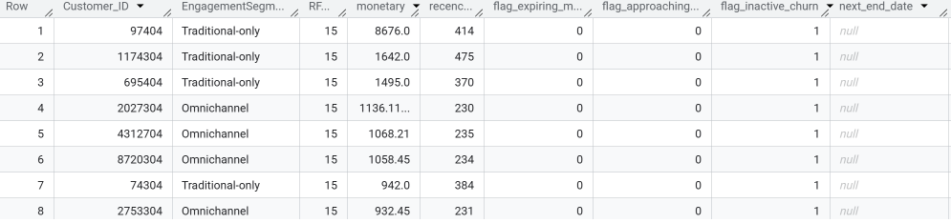
Visualisation

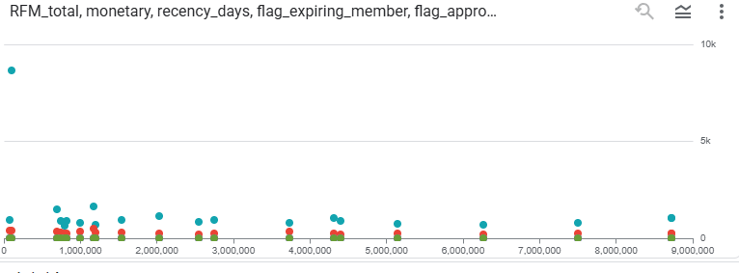
Query 2.5 - Campaign save-rate for expiring members after contact
CREATE OR REPLACE VIEW `assignment-3-474608.assign3.vw_campaign_save_rate` AS
WITH
expiring AS (
SELECT DISTINCT
t.Customer_ID,
MIN(DATE(t.DonationEndDate)) AS end_date
FROM
`assignment-3-474608`.assign3.Tradition_Donation_Patterns AS t
WHERE
LOWER(t.Product) = 'membership' AND t.DonationEndDate IS NOT NULL
GROUP BY t.Customer_ID
),
touch AS (
SELECT
r.Customer_ID,
r.Campaign_ID,
m.CampaignType,
DATE(m.CampaignDate) AS CampaignDate,
`IF`(LOWER(TRIM(CAST(r.Response AS STRING))) IN ('yes', 'y', '1', 'true'), 1, 0) AS responded
FROM
`assignment-3-474608`.assign3.Campaign_Response AS r
JOIN
`assignment-3-474608`.assign3.Marketing_Campaigns AS m
ON r.Campaign_ID = m.Campaign_ID
),
renewals AS (
SELECT
t.Customer_ID,
MIN(DATE(t.DonationDate)) AS first_post_campaign_membership
FROM
`assignment-3-474608`.assign3.Tradition_Donation_Patterns AS t
WHERE
LOWER(t.Product) = 'membership'
GROUP BY t.Customer_ID
)
SELECT
t.Campaign_ID,
t.CampaignType,
COUNT(DISTINCT t.Customer_ID) AS expiring_contacted,
AVG(t.responded) AS campaign_response_rate,
AVG(
CASE
WHEN r.first_post_campaign_membership IS NOT NULL AND DATE_DIFF(r.first_post_campaign_membership, t.CampaignDate,
DAY) BETWEEN 0 AND 60 THEN 1
ELSE 0
END) AS save_rate_within_window
FROM
touch AS t
JOIN
expiring AS e
ON e.Customer_ID = t.Customer_ID
LEFT JOIN
renewals AS r
ON r.Customer_ID = t.Customer_ID
GROUP BY t.Campaign_ID, t.CampaignType
ORDER BY save_rate_within_window DESC;

SELECT * FROM `assignment-3-474608.assign3.vw_campaign_save_rate` LIMIT 20;

Output

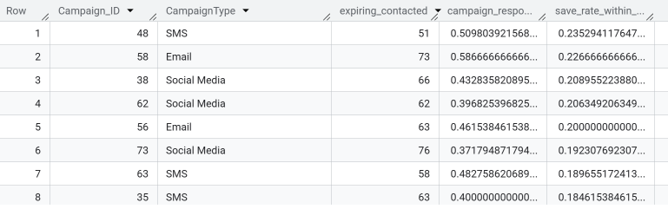

Visualisation

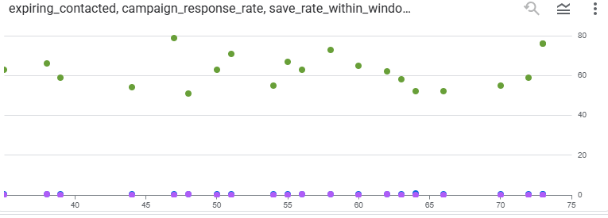
Query 2.6 - “Who gets what” — ready-to-export targeting lists

SELECT
s.Customer_ID,
s.next_end_date AS membership_end_date,
r.RFM_total, r.monetary, seg.EngagementSegment
FROM `assignment-3-474608.assign3.vw_churn_risk_save_list` s
JOIN `assignment-3-474608.assign3.vw_customer_rfm` r USING (Customer_ID)
JOIN `assignment-3-474608.assign3.vw_engagement_segments` seg USING (Customer_ID)
WHERE s.flag_expiring_member = 1
ORDER BY r.RFM_total DESC, r.monetary DESC
LIMIT 200;

-- 2) Approaching inactivity (120–179 days): light-touch nudges
SELECT
s.Customer_ID,
s.recency_days,
r.RFM_total, r.monetary, seg.EngagementSegment
FROM `assignment-3-474608.assign3.vw_churn_risk_save_list` s
JOIN `assignment-3-474608.assign3.vw_customer_rfm` r USING (Customer_ID)
JOIN `assignment-3-474608.assign3.vw_engagement_segments` seg USING (Customer_ID)
WHERE s.flag_approaching_inactive = 1
ORDER BY r.monetary DESC, r.RFM_total DESC
LIMIT 200;

-- 3) Already inactive (≥180 days): reactivation journey
SELECT
s.Customer_ID,
s.recency_days,
r.RFM_total, r.monetary, seg.EngagementSegment
FROM `assignment-3-474608.assign3.vw_churn_risk_save_list` s
JOIN `assignment-3-474608.assign3.vw_customer_rfm` r USING (Customer_ID)
JOIN `assignment-3-474608.assign3.vw_engagement_segments` seg USING (Customer_ID)
WHERE s.flag_inactive_churn = 1
ORDER BY r.monetary DESC, r.RFM_total DESC
LIMIT 200;

Output

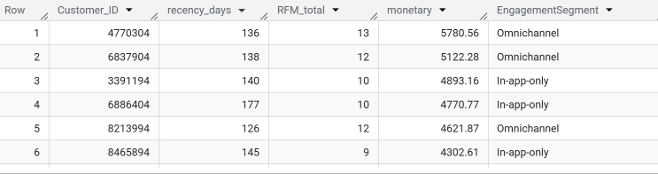

Visualisation

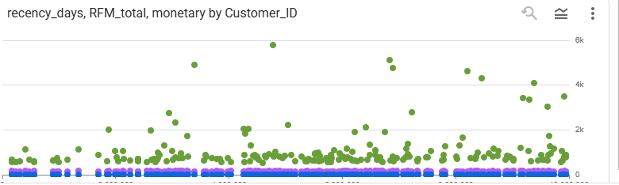

3. Measuring Donor Retention
Query 3.1 – Cohort Retention Analysis
This query groups donors by their first active month (cohort) and calculates monthly donor retention rates by cohort (based on each donor's first contribution month). It also tracks what proportion of each cohort remains active after 1, 3, 6 months, etc. and helps visualize how well donors continue to engage over time.
Query:
DECLARE start_date DATE DEFAULT DATE '2024-01-01';
DECLARE end_date DATE DEFAULT DATE '2025-08-31';

WITH trad AS (
SELECT CAST(Customer_ID AS STRING) AS Customer_ID,
DATE(DonationDate) AS EventDate,
DATE_TRUNC(DATE(DonationDate), MONTH) AS EventMonth
FROM `manjil-shrestha.A3.Tradition_Donation_Patterns`
WHERE DonationDate IS NOT NULL
),
mobile AS (
SELECT CAST(Customer_ID AS STRING) AS Customer_ID,
DATE(LastPurchaseDate) AS EventDate,
DATE_TRUNC(DATE(LastPurchaseDate), MONTH) AS EventMonth
FROM `manjil-shrestha.A3.Mobile_Game_Inapp_Purchases`
WHERE LastPurchaseDate IS NOT NULL AND InAppPurchaseAmount > 0
),
contrib AS (
SELECT * FROM trad
UNION ALL
SELECT * FROM mobile
),
cohort AS (
SELECT Customer_ID, MIN(EventMonth) AS CohortMonth
FROM contrib
GROUP BY Customer_ID
),
active AS (
SELECT DISTINCT Customer_ID, EventMonth AS MonthActive
FROM contrib
),
activity AS (
SELECT c.CohortMonth, a.MonthActive,
DATE_DIFF(a.MonthActive, c.CohortMonth, MONTH) AS MonthsSince,
COUNT(DISTINCT a.Customer_ID) AS ActiveCustomers
FROM cohort c
JOIN active a USING (Customer_ID)
WHERE a.MonthActive >= c.CohortMonth
GROUP BY 1,2,3
),
size AS (
SELECT CohortMonth, COUNT(DISTINCT Customer_ID) AS CohortSize
FROM cohort
GROUP BY CohortMonth
)
SELECT a.CohortMonth, a.MonthsSince, a.ActiveCustomers, s.CohortSize,
SAFE_DIVIDE(a.ActiveCustomers, s.CohortSize) AS RetentionRate
FROM activity a
JOIN size s USING (CohortMonth)
ORDER BY CohortMonth, MonthsSince;

Output:

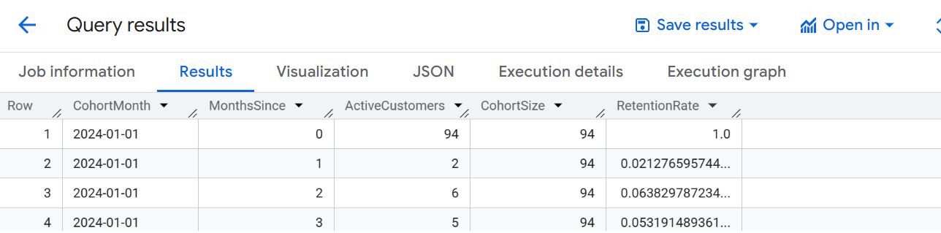
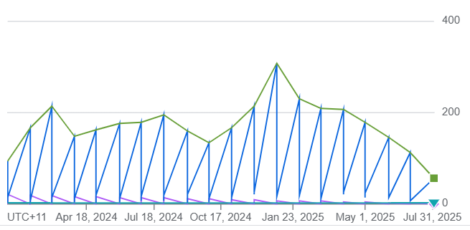
Query 2 – Month-to-Month Retention
This query identifies donors who appear in both consecutive months, measures short-term retention trends and Calculates the proportion of donors active this month who were also active last month.
Query:
DECLARE start_date DATE DEFAULT DATE '2024-01-01';
DECLARE end_date DATE DEFAULT DATE '2025-08-31';

WITH trad AS (
SELECT CAST(Customer_ID AS STRING) AS Customer_ID,
DATE_TRUNC(DATE(DonationDate), MONTH) AS m
FROM `manjil-shrestha.A3.Tradition_Donation_Patterns`
WHERE DonationDate IS NOT NULL
),
mobile AS (
SELECT CAST(Customer_ID AS STRING) AS Customer_ID,
DATE_TRUNC(DATE(LastPurchaseDate), MONTH) AS m
FROM `manjil-shrestha.A3.Mobile_Game_Inapp_Purchases`
WHERE LastPurchaseDate IS NOT NULL AND InAppPurchaseAmount > 0
),
active AS (
SELECT Customer_ID, m FROM trad
UNION DISTINCT
SELECT Customer_ID, m FROM mobile
),
months AS (
SELECT m
FROM UNNEST(GENERATE_DATE_ARRAY(start_date, end_date, INTERVAL 1 MONTH)) AS m
),
curr AS (
SELECT m, ARRAY_AGG(DISTINCT Customer_ID) AS donors
FROM active
GROUP BY m
),
prev AS (
SELECT DATE_ADD(m, INTERVAL 1 MONTH) AS m, ARRAY_AGG(DISTINCT Customer_ID) AS donors_prev
FROM active
GROUP BY m
)
SELECT
mo.m AS Month,
ARRAY_LENGTH(IFNULL(cu.donors, [])) AS ActiveDonors,
ARRAY_LENGTH(
ARRAY(
SELECT x
FROM UNNEST(IFNULL(cu.donors, [])) AS x
WHERE x IN UNNEST(IFNULL(pr.donors_prev, []))
)
) AS RetainedFromLastMonth,
SAFE_DIVIDE(
ARRAY_LENGTH(
ARRAY(
SELECT x
FROM UNNEST(IFNULL(cu.donors, [])) AS x
WHERE x IN UNNEST(IFNULL(pr.donors_prev, []))
)
),
NULLIF(ARRAY_LENGTH(IFNULL(pr.donors_prev, [])), 0)
) AS RetentionRate_MoM
FROM months mo
LEFT JOIN curr cu USING (m)
LEFT JOIN prev pr USING (m)
ORDER BY Month;

Output:

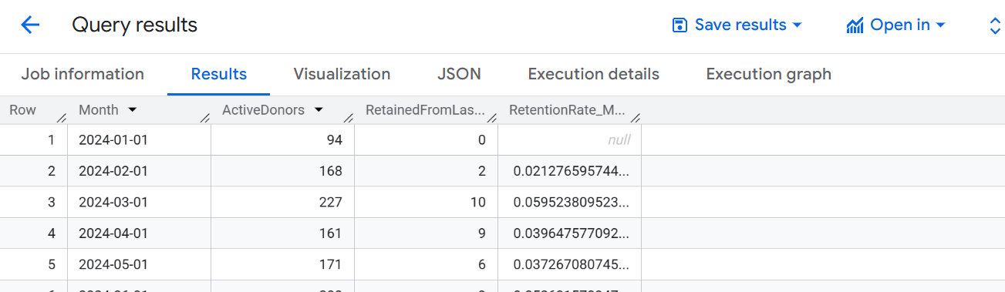
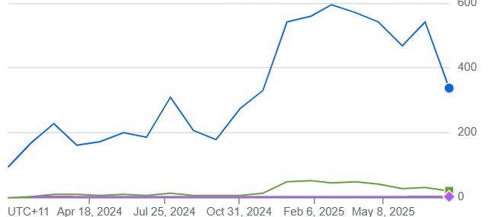
PART B: Finding High-Impact Contributors
Query 3 – RFM & Top Decile Donors
This Query assigns each donor Recency (R), Frequency (F), and Monetary (M) scores from 1–5 and Combines these into a weighted composite (R:40%, F:30%, M:30%).Here, if ValueDecile = 1 → top 10% contributors and IsChurned = TRUE → donors who canceled membership or inactive for 90+ days.
Query:
DECLARE start_date DATE DEFAULT DATE '2024-01-01';
DECLARE end_date DATE DEFAULT DATE '2025-08-31';

WITH trad AS (
SELECT CAST(Customer_ID AS STRING) AS Customer_ID,
DATE(DonationDate) AS EventDate,
CAST(DonationAmount AS NUMERIC) AS Amount
FROM `manjil-shrestha.A3.Tradition_Donation_Patterns`
WHERE DonationDate IS NOT NULL
),
mobile AS (
SELECT CAST(Customer_ID AS STRING) AS Customer_ID,
DATE(LastPurchaseDate) AS EventDate,
CAST(InAppPurchaseAmount AS NUMERIC) AS Amount
FROM `manjil-shrestha.A3.Mobile_Game_Inapp_Purchases`
WHERE LastPurchaseDate IS NOT NULL AND InAppPurchaseAmount > 0
),
contrib AS (
SELECT * FROM trad
UNION ALL
SELECT * FROM mobile
),
kpis AS (
SELECT Customer_ID,
SUM(Amount) AS TotalContribution,
COUNT(*) AS NumContributionEvents,
MAX(EventDate) AS LastEventDate
FROM contrib
WHERE EventDate BETWEEN start_date AND end_date
GROUP BY Customer_ID
),
membership_cancel AS (
SELECT CAST(Customer_ID AS STRING) AS Customer_ID,
MAX(DATE(DonationEndDate)) AS LastCancelDate
FROM `manjil-shrestha.A3.Tradition_Donation_Patterns`
WHERE Product = 'Membership'
GROUP BY Customer_ID
)
SELECT k.Customer_ID,
k.TotalContribution,
k.NumContributionEvents,
k.LastEventDate,
DATE_DIFF(end_date, k.LastEventDate, DAY) AS DaysSinceLast,
NTILE(5) OVER (ORDER BY -TotalContribution) AS M_score,
NTILE(5) OVER (ORDER BY -NumContributionEvents) AS F_score,
NTILE(5) OVER (ORDER BY DATE_DIFF(end_date, k.LastEventDate, DAY)) AS R_score,
NTILE(10) OVER (ORDER BY -TotalContribution) AS ValueDecile,
ROUND(0.4*NTILE(5) OVER (ORDER BY DATE_DIFF(end_date, k.LastEventDate, DAY)) +
0.3*NTILE(5) OVER (ORDER BY -NumContributionEvents) +
0.3*NTILE(5) OVER (ORDER BY -TotalContribution), 2) AS RFM_Composite,
CASE
WHEN mc.LastCancelDate IS NOT NULL THEN TRUE
WHEN DATE_DIFF(end_date, k.LastEventDate, DAY) > 90 THEN TRUE
ELSE FALSE
END AS IsChurned
FROM kpis k
LEFT JOIN membership_cancel mc USING (Customer_ID)
ORDER BY ValueDecile, TotalContribution DESC;

Output:
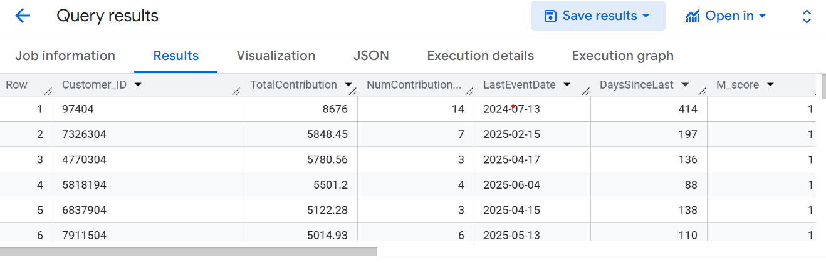

4.1 Personalized Outreach: Donor Segmentation
WITH Traditional_RFM AS (
SELECT
Customer_ID,
MAX(DonationDate) AS LastDonationDate,
COUNT(Donation_ID) AS Frequency,
SUM(DonationAmount) AS Monetary,
DATE_DIFF(DATE('2025-08-31'), MAX(DonationDate), DAY) AS Recency
FROM `braided-potion-474408-p9.MobileImpact.Tradition_Donation_Patterns`
WHERE DonationDate BETWEEN DATE('2024-01-01') AND DATE('2025-08-31')
GROUP BY Customer_ID
),
Ranked_Traditional_RFM AS (
SELECT
Customer_ID,
LastDonationDate,
Frequency,
Monetary,
Recency,
6 - NTILE(5) OVER (ORDER BY Recency DESC) AS Recency_Quintile,
NTILE(5) OVER (ORDER BY Frequency) AS Frequency_Quintile,
NTILE(5) OVER (ORDER BY Monetary) AS Monetary_Quintile
FROM Traditional_RFM
),
InApp_RFM AS (
SELECT
Customer_ID,
MAX(LastPurchaseDate) AS LastPurchaseDate,
COUNT(LastPurchaseDate) AS Frequency,
SUM(InAppPurchaseAmount) AS Monetary,
DATE_DIFF(DATE('2025-08-31'), MAX(LastPurchaseDate), DAY) AS Recency
FROM `braided-potion-474408-p9.MobileImpact.Mobile_Game_Inapp_Purchases`
WHERE LastPurchaseDate BETWEEN DATE('2024-01-01') AND DATE('2025-08-31')
GROUP BY Customer_ID
),
Ranked_InApp_RFM AS (
SELECT
Customer_ID,
LastPurchaseDate,
Frequency,
Monetary,
Recency,
6 - NTILE(5) OVER (ORDER BY Recency DESC) AS Recency_Quintile,
NTILE(5) OVER (ORDER BY Frequency) AS Frequency_Quintile,
NTILE(5) OVER (ORDER BY Monetary) AS Monetary_Quintile
FROM InApp_RFM
)

SELECT
c.Customer_ID,
c.Age,
c.Income_Level,

-- Age Group Classification
CASE
WHEN c.Age < 25 THEN '<25'
WHEN c.Age BETWEEN 25 AND 34 THEN '25-34'
WHEN c.Age BETWEEN 35 AND 44 THEN '35-44'
WHEN c.Age BETWEEN 45 AND 54 THEN '45-54'
WHEN c.Age BETWEEN 55 AND 64 THEN '55-64'
ELSE '65+'
END AS Age_Group,

-- Traditional RFM ranks
CONCAT(
CAST(t.Recency_Quintile AS STRING),
CAST(t.Frequency_Quintile AS STRING),
CAST(t.Monetary_Quintile AS STRING)
) AS Traditional_RFM_Rank,

-- In-App RFM ranks
CONCAT(
CAST(i.Recency_Quintile AS STRING),
CAST(i.Frequency_Quintile AS STRING),
CAST(i.Monetary_Quintile AS STRING)
) AS InApp_RFM_Rank,

-- Engagement classifications
CASE
WHEN t.Recency_Quintile >= 4 AND t.Frequency_Quintile >= 4 AND t.Monetary_Quintile >= 4 THEN 'High Traditional Engagement'
WHEN t.Recency_Quintile >= 3 AND t.Frequency_Quintile >= 3 AND t.Monetary_Quintile >= 3 THEN 'Medium Traditional Engagement'
ELSE 'Low Traditional Engagement'
END AS Traditional_Engagement_Group,

CASE
WHEN i.Recency_Quintile >= 4 AND i.Frequency_Quintile >= 4 AND i.Monetary_Quintile >= 4 THEN 'High InApp Engagement'
WHEN i.Recency_Quintile >= 3 AND i.Frequency_Quintile >= 3 AND i.Monetary_Quintile >= 3 THEN 'Medium InApp Engagement'
ELSE 'Low InApp Engagement'
END AS InApp_Engagement_Group

FROM `braided-potion-474408-p9.MobileImpact.Customers` c
LEFT JOIN Ranked_Traditional_RFM t ON c.Customer_ID = t.Customer_ID
LEFT JOIN Ranked_InApp_RFM i ON c.Customer_ID = i.Customer_ID

ORDER BY Age_Group, Traditional_Engagement_Group DESC, InApp_Engagement_Group DESC;

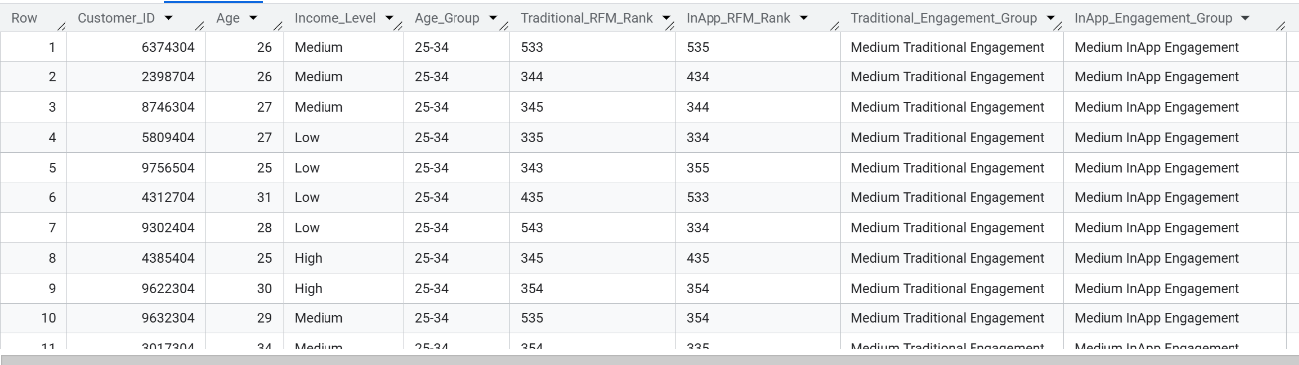
Output
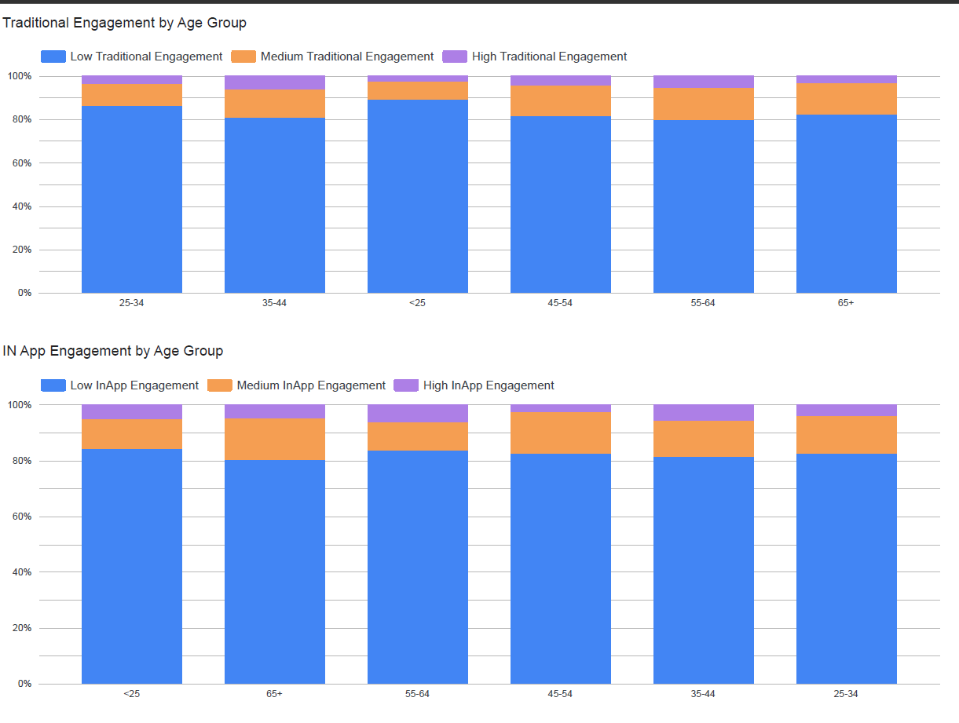
Visualisation
4.2 Dynamic Campaign Messaging
WITH Customer_Campaign AS (
SELECT
Customer_ID,
Campaign_ID,
MAX(Response) AS Response,
AVG(ClickThroughRate) AS Avg_CTR,
SUM(EngagementFrequency) AS Total_Engagement
FROM `braided-potion-474408-p9.MobileImpact.Campaign_Response`
GROUP BY Customer_ID, Campaign_ID
),

Traditional_RFM AS (
SELECT
Customer_ID,
MAX(DonationDate) AS LastDonationDate,
COUNT(Donation_ID) AS Frequency,
SUM(DonationAmount) AS Monetary,
DATE_DIFF(DATE('2025-08-31'), MAX(DonationDate), DAY) AS Recency
FROM `braided-potion-474408-p9.MobileImpact.Tradition_Donation_Patterns`
WHERE DonationDate BETWEEN DATE('2024-01-01') AND DATE('2025-08-31')
GROUP BY Customer_ID
),

Ranked_Traditional_RFM AS (
SELECT
Customer_ID,
6 - NTILE(5) OVER (ORDER BY Recency DESC) AS Recency_Quintile,
NTILE(5) OVER (ORDER BY Frequency) AS Frequency_Quintile,
NTILE(5) OVER (ORDER BY Monetary) AS Monetary_Quintile
FROM Traditional_RFM
),

Traditional_Engagement AS (
SELECT
c.Customer_ID,
CASE
WHEN c.Age < 25 THEN '<25'
WHEN c.Age BETWEEN 25 AND 34 THEN '25-34'
WHEN c.Age BETWEEN 35 AND 44 THEN '35-44'
WHEN c.Age BETWEEN 45 AND 54 THEN '45-54'
WHEN c.Age BETWEEN 55 AND 64 THEN '55-64'
ELSE '65+'
END AS Age_Group,
CASE
WHEN t.Recency_Quintile >= 4 AND t.Frequency_Quintile >= 4 AND t.Monetary_Quintile >= 4 THEN 'High Traditional Engagement'
WHEN t.Recency_Quintile >= 3 AND t.Frequency_Quintile >= 3 AND t.Monetary_Quintile >= 3 THEN 'Medium Traditional Engagement'
ELSE 'Low Traditional Engagement'
END AS Engagement_Group
FROM `braided-potion-474408-p9.MobileImpact.Customers` c
LEFT JOIN Ranked_Traditional_RFM t ON c.Customer_ID = t.Customer_ID
)

SELECT
te.Age_Group,
te.Engagement_Group,
mc.CampaignType,
COUNT(DISTINCT cc.Customer_ID) AS Num_Customers_Responded,
SUM(CASE WHEN cc.Response = TRUE THEN 1 ELSE 0 END) AS Positive_Responses,
SAFE_DIVIDE(SUM(CASE WHEN cc.Response = TRUE THEN 1 ELSE 0 END), COUNT(DISTINCT cc.Customer_ID)) AS Response_Rate,
AVG(cc.Avg_CTR) AS Avg_CTR,
AVG(cc.Total_Engagement) AS Avg_Engagement_Frequency
FROM Traditional_Engagement te
LEFT JOIN Customer_Campaign cc ON te.Customer_ID = cc.Customer_ID
LEFT JOIN `braided-potion-474408-p9.MobileImpact.Marketing_Campaigns` mc
ON cc.Campaign_ID = mc.Campaign_ID
GROUP BY te.Age_Group, te.Engagement_Group, mc.CampaignType
ORDER BY te.Age_Group, te.Engagement_Group DESC, Response_Rate DESC;

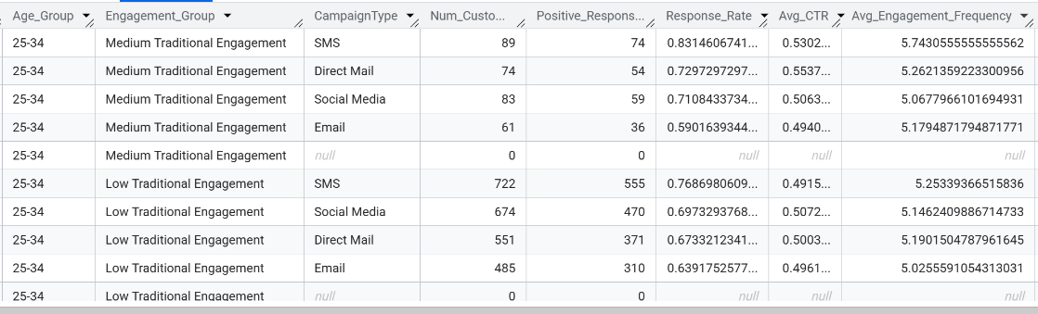
Output

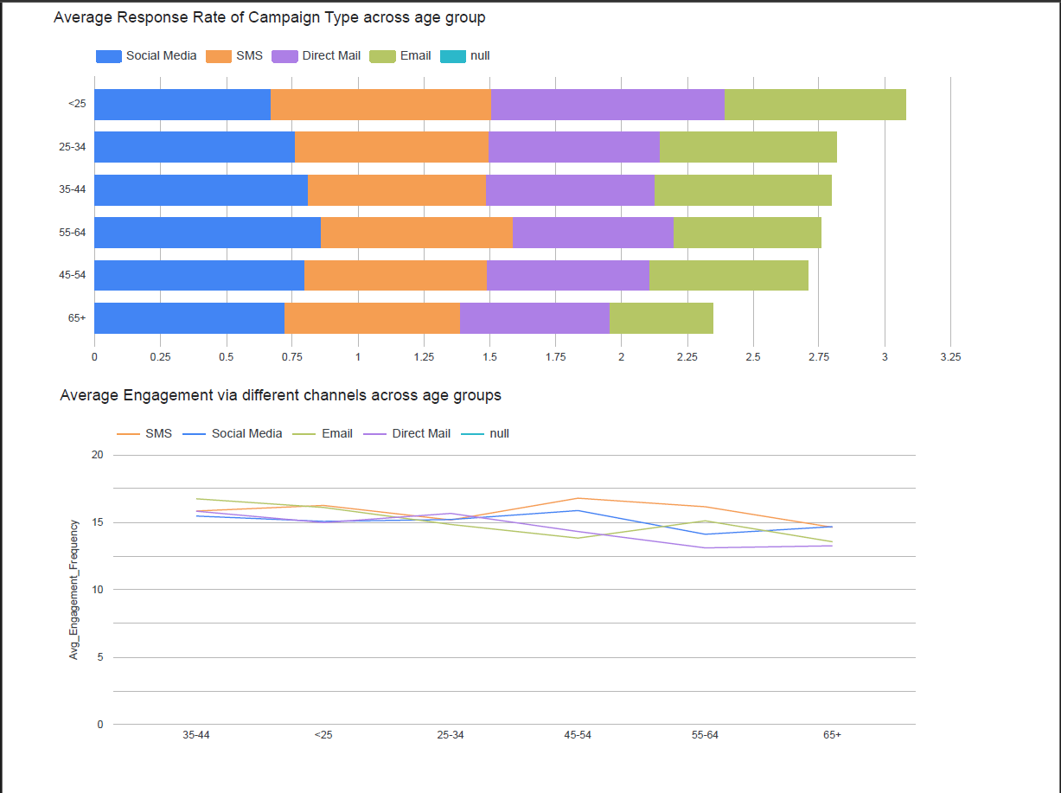
Visualisation

4.3 App-Based Incentives
WITH InApp_Summary AS (
SELECT
c.Customer_ID,
c.Age,
c.Income_Level,
i.GameGenre,
i.SpendingSegment,
SUM(i.InAppPurchaseAmount) AS Total_InApp_Purchase,
COUNT(i.LastPurchaseDate) AS SessionCount,
AVG(i.AverageSessionLength) AS Avg_Session_Length
FROM `braided-potion-474408-p9.MobileImpact.Customers` c
LEFT JOIN `braided-potion-474408-p9.MobileImpact.Mobile_Game_Inapp_Purchases` i
ON c.Customer_ID = i.Customer_ID
WHERE i.LastPurchaseDate BETWEEN DATE('2024-01-01') AND DATE('2025-08-31')
GROUP BY c.Customer_ID, c.Age, c.Income_Level, i.GameGenre, i.SpendingSegment
),

Ranked_InApp_RFM AS (
SELECT
Customer_ID,
6 - NTILE(5) OVER (ORDER BY DATE_DIFF(DATE('2025-08-31'), MAX(LastPurchaseDate), DAY) DESC) AS Recency_Quintile,
NTILE(5) OVER (ORDER BY COUNT(LastPurchaseDate)) AS Frequency_Quintile,
NTILE(5) OVER (ORDER BY SUM(InAppPurchaseAmount)) AS Monetary_Quintile
FROM `braided-potion-474408-p9.MobileImpact.Mobile_Game_Inapp_Purchases`
GROUP BY Customer_ID
)

SELECT
s.Customer_ID,

-- Age Group Segmentation
CASE
WHEN s.Age < 25 THEN '<25'
WHEN s.Age BETWEEN 25 AND 34 THEN '25-34'
WHEN s.Age BETWEEN 35 AND 44 THEN '35-44'
WHEN s.Age BETWEEN 45 AND 54 THEN '45-54'
WHEN s.Age BETWEEN 55 AND 64 THEN '55-64'
ELSE '65+'
END AS Age_Group,

s.Income_Level,
s.GameGenre,
s.SpendingSegment,
s.Total_InApp_Purchase,
s.SessionCount,
s.Avg_Session_Length,

-- In-App Engagement Level
CASE
WHEN r.Recency_Quintile >= 4 AND r.Frequency_Quintile >= 4 AND r.Monetary_Quintile >= 4 THEN 'High InApp Engagement'
WHEN r.Recency_Quintile >= 3 AND r.Frequency_Quintile >= 3 AND r.Monetary_Quintile >= 3 THEN 'Medium InApp Engagement'
ELSE 'Low InApp Engagement'
END AS InApp_Engagement_Group

FROM InApp_Summary s
LEFT JOIN Ranked_InApp_RFM r
ON s.Customer_ID = r.Customer_ID
ORDER BY Age_Group, InApp_Engagement_Group DESC, Total_InApp_Purchase DESC

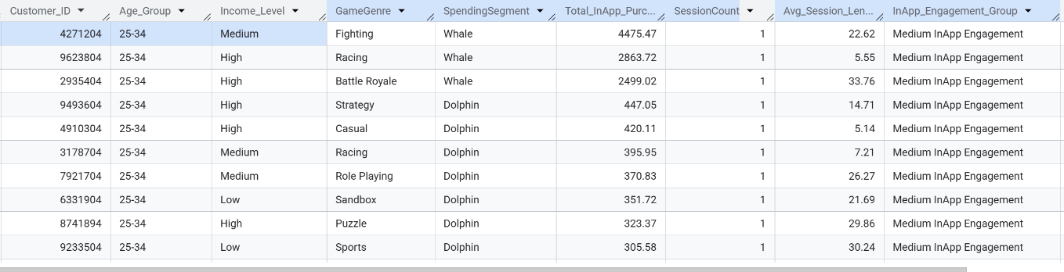
Output

Visualisation
